Gym Management Database Design Document

Course: Harvard CS50’s Introduction to Databases with SQL
Database Engine: SQLite
Project Author: Samuel Levin

1. Introduction
This document describes the design of a relational database system that models the operations of a fitness gym. The database supports membership management, staff assignments, class scheduling, billing, and attendance tracking. It is implemented in SQLite and accessed via automated batch files that execute predefined SQL scripts.

1.1 Objective
The purpose of this document is to define the database schema, constraints, and data access design for the Gym Management System. It provides a foundation for implementation, review, and maintenance.

1.2 Intended Audience
This document is intended for technical reviewers, database developers, and stakeholders who require insight into the logical and physical design of the gym database system.

2. System Overview
The Gym Management Database serves as the core data store for all operational and analytical needs of the gym. It supports both daily transactions (e.g., class enrollments, check-ins) and analytical reporting (e.g., monthly revenue, member retention, class utilization). The database interacts with user-friendly batch files that automate data queries and updates.

3. Design Considerations
Key design considerations include:
- • Maintain historical membership data for retention analysis.
- • Enforce referential integrity through foreign key constraints.
- • Prevent duplicate enrollments via unique constraints.
- • Ensure scalability through proper indexing on common query paths.

4. Logical Design
The database schema models gym operations using normalized tables that capture members, memberships, staff, classes, schedules, enrollments, transactions, and attendance. The design adheres to Third Normal Form (3NF) to eliminate redundancy and ensure data integrity.
Key Entities:
- members – Member demographic and contact details.
- memberships – Catalog of available membership plans.
- member_membership_history – Tracks membership history with start and end dates.
- staff – Gym employees including instructors and administrators.
- rooms – Physical locations where classes take place.
- classes – Template definitions for fitness classes.
- schedules – Links classes, rooms, and instructors to specific time slots.
- class_enrollments – Tracks which members are enrolled in each class schedule.
- attendance – Member check-ins and visit durations.
- transactions – Financial transactions for memberships and other services.

5. Physical Design
The database enforces integrity through the following constraint mechanisms:
- FOREIGN KEY constraints with ON DELETE actions.
- CHECK constraints to control status and transaction type values.
- UNIQUE constraints on member and staff emails.
- Composite UNIQUE(member_id, schedule_id) in class_enrollments to avoid double booking.
Indexing Strategy:
- Composite indexes on member_id/date for transactions.
- Indexes on enrollment status and schedule_id for faster reporting.

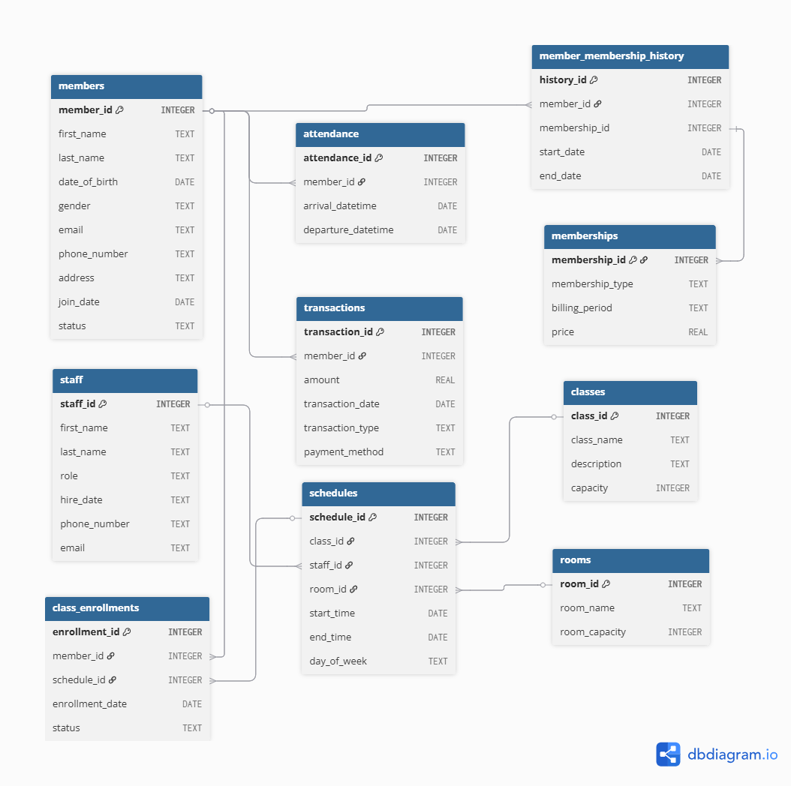
6. Data Dictionary Diagram

7. Batch File Interface Instructions
Several Windows batch script tools were implemented to simplify user interaction with the database. Each script calls SQLite with prewritten SQL queries and formatted output.
To see help for a specific tool, run tool.bat /?. (E.g.
Member.bat /?)
- all_mem.bat – Find a list of members in members table
Usage: pass one arguments: num_members
Description: This batch file provides a list of members in the club.
Example: all_mem.bat 5
- member.bat – Find a specific member in members table
Usage: member.bat first_name last_name
Description: This batch file retrieves member data for the specified member. You must provide exactly two string arguments.
Example: member.bat Samuel Lenin
- all_cl.bat – List out however many classes you want to look at
Usage: all_cl.bat num_rows
Description: This batch file retrieves the top N classes from the database. You must provide exactly one numeric argument.
Example: all_cl.bat 3
- all_memberships.bat – Find a certain number of memberships from the database
Usage: all_memberships.bat num_rows
Description: This batch file lists the top N classes from the database.
Example: all_memberships.bat 10
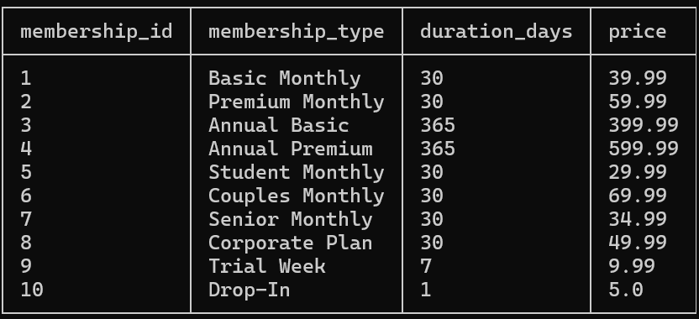
- memberships.bat – Find members’ active memberships
Usage: memberships.bat first_name last_name
Description: This batch file retrieves membership data for the specified member. You must provide exactly two string arguments.
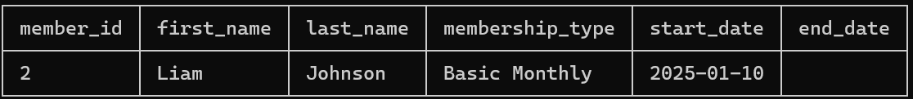
Example: memberships.bat Liam Johnson
- usrenr.bat – Find specific members enrolled in any class
Usage: usrenr.bat FirstName LastName
Description: This batch file allows a user to see the class(es) that he/she has enrolled in
Example: usrenr.bat Liam Johnson

Register for class: usrenr.bat /r FirstName LastName "Class Name" DayOfWeek StartTime
Example: usrenr.bat /r Samuel Lenin "Yoga Basics" Wednesday 07:00
Cancel a registration: usrenr.bat /cancel FirstName LastName "Class Name" DayOfWeek StartTime
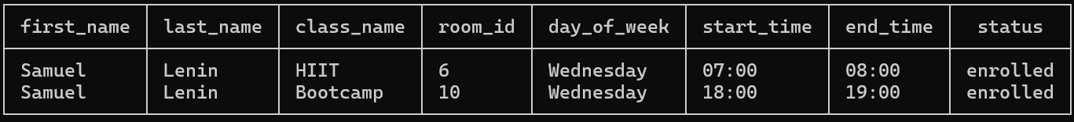
Example: usrenr.bat /cancel Samuel Lenin HIIT Wednesday 07:00
- cl_info.bat
Usage: cl_info.bat class_name
Description: This batch file retrieves info for any specific class you want.
Example: cl_info.bat Bootcamp
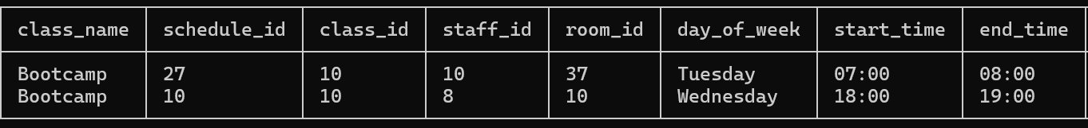
- Room.bat – Find the room the associated class is going to be held in
Usage: pass one arguments: room_id
Description: This batch file lists a room that the class you registered for is happening in.
Example: room.bat 17

Room name lookup:
- usrenr first_name last_name in terminal to find class you enrolled in along with the room_id
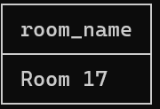
- room.bat room_id to find the room name

- Payments.bat – View payments by member
Usage: payments.bat first_name last_name
Description: This batch file queries all payments for the specified member. You must provide exactly two string arguments.
Example: payments.bat Liam Johnson

9. Future Enhancements
• Integration with a web-based dashboard for analytics visualization.
• Terminal front-end framework for a visual appeal, user friendly, and feel more productized
• Support for mobile notifications about class availability.
• Pre-train an LLM to generate queries from text.

